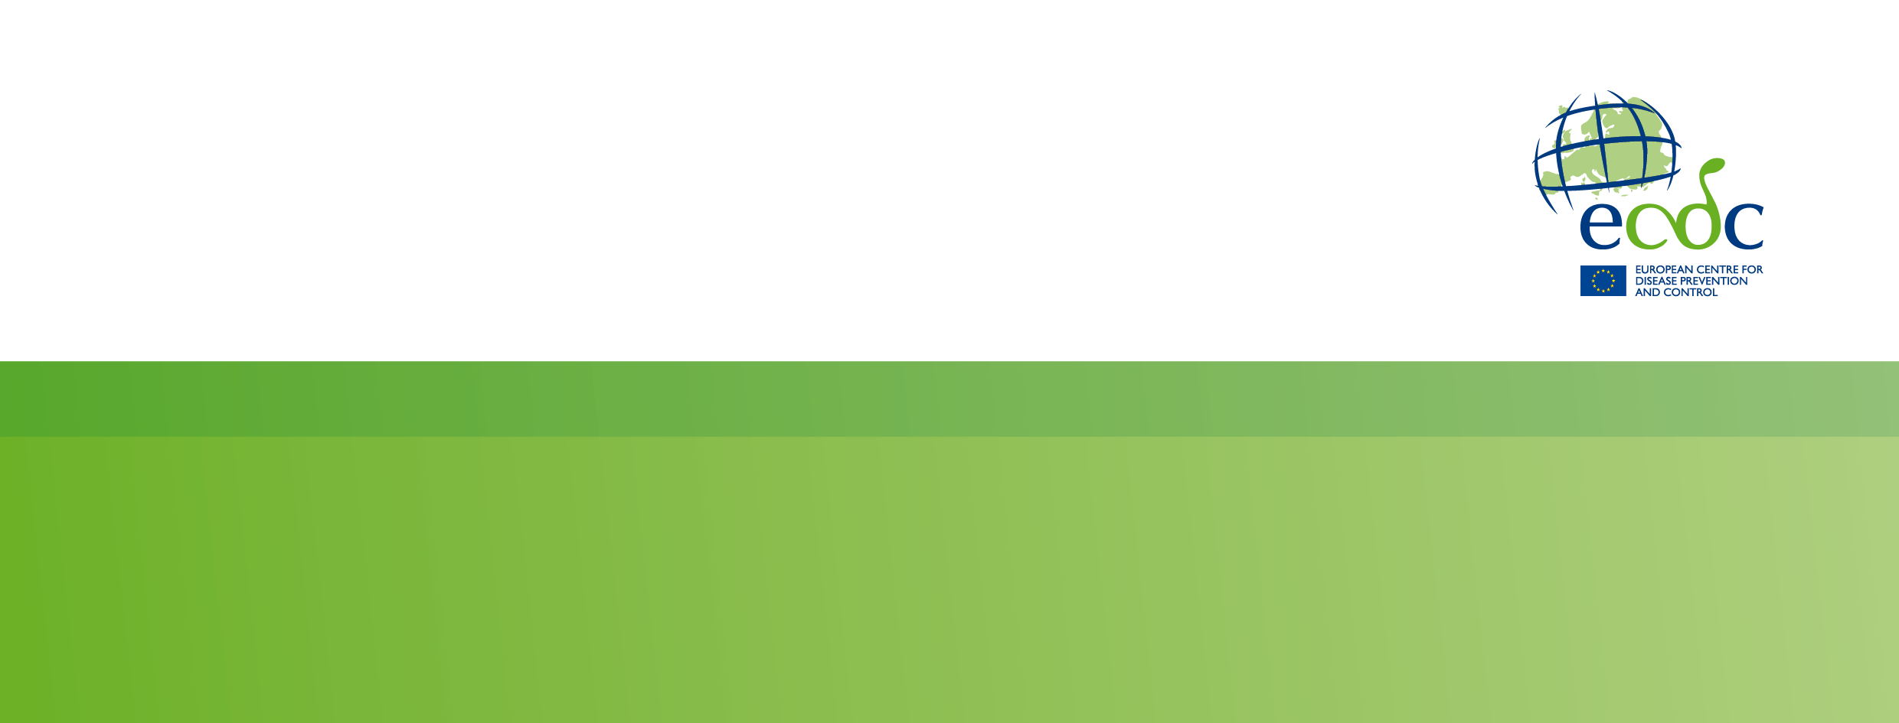

Vaccination communication toolkit guidelines

Background

On the basis of the study on vaccination information uptake, ECDC developed editable communication materials to raise awareness of the European Vaccination Information Portal (EVIP) and ensure that people have the information they need to make informed decisions.

The communication toolkit is comprised of various printed materials and social media content and aims to:
- Improve health literacy on vaccine science and counter mis- and disinformation through the provision of factual and unbiased information;
- Contribute to increased vaccination uptake in European Union/European Economic Area (EU/EEA) countries for COVID-19 and other diseases; and
- Support/enable National Focal Points’ (NFP) national campaigns.

The materials are designed for national authorities to further distribute these materials to participating health professionals, such as general practitioners (GPs)/family physicians, paediatricians, student health centres, other medical specialists, nurses, pharmacists, and health educators.

All materials were developed following communication theoretical frameworks, tested before use and translated into all EU/EEA languages. The content developed was produced in a style that ensures it is approachable, engaging, concise and shareable. It is also geared to meet people’s needs and expectations when they are searching for information about vaccination.

This guidance document was prepared for national and local authorities on how to adapt, contextualise and use the materials. The materials developed are made available on EVIP and intended to be used by different partners for risk communication purposes.

Study on vaccination information uptake – results

The overarching purpose of this study was to improve the understanding of how the general public and healthcare professionals seek, use and share information about vaccines and vaccinations. The results were used to inform the further development of EVIP and support the creation of re-usable communication materials to help EU/EEA countries in their communication initiatives on vaccination.

Based on the results from the focus group study, recommendations for communicating with patients on vaccines/vaccinations were made related to three elements of communication:
- What is communicated to patients (content and framing of content);
- How the information is communicated to patients (format and channel use); and
- Who communicates to patients (messenger).

Recommendations on content and framing of content

Following the findings from both the general public and the healthcare professionals focus groups, communication materials aimed at informing the public are advised to include the following content/information:
- The necessity/importance of getting vaccinated;
- The safety of the vaccine, including information on side effects and ingredients of the vaccine/ how the vaccine works;
- Practicalities, including information about the vaccination schedule, age-specific recommendations, price and logistics (e.g. where to get vaccinated).
This information should preferably be shared using simple and accessible language that does not contain too many medical terms, and with specific reference to the national vaccination context and guidelines.

Focus group participants indicated that they are most likely to search for information on COVID-19 vaccines, influenza vaccines, HPV vaccines, pneumococcal vaccines, and travel vaccines. As a result, the informational material created mainly focused on these topics.

The results also showed that the effectiveness of information about vaccines/vaccinations often depends on the content framing strategies used to convey a message, and the discourse and tone of the communication. It is particularly important that content catches people’s attention in a meaningful way, enabling patients to relate the message to their own lives. Two framing strategies were identified that might be beneficial in raising awareness on the topic of vaccines/vaccinations by presenting a message that is more personally meaningful:
- Using images and keywords or slogans that speak to patients emotionally (e.g. connecting the benefits of vaccination to living a longer life, and therefore being able to enjoy as much time as possible with grand-children).
- Speaking to patients’ sense of responsibility (e.g. vaccination is not only a way to take care of one’s own health, but also to protect society as a whole).

Note that it was specified that it is important that the information shared by European health authorities is country-specific and in the local language/s.

Recommendations regarding format and channel use

For both digital and printed information, the results showed that it is important to present information in a well-structured format. For online information, this includes:
- Summarising the key takeaways at the start of the webpage;
- Using clear subheadings;
- Providing Q&A formats;
- Implementing the same structure for each vaccine/vaccination that is presented;
- Collating all relevant information on one website; and
- Including hyperlinks to (other) scientific websites for more information (increasing perceived reliability of the provided information).

Additionally, an attractive layout is indispensable to catch people’s attention, for both digital and printed information, which includes visual elements such as:
- Tables and graphs presenting simple statistical data;
- Infographics;
- Relevant images that speak to the target audience;
- Short videos; and
- The logo of the messenger (to add credibility).
A distinction needs to be made between channels that are deemed useful for raising awareness (e.g. traditional mass media and posters), and channels that are being used to obtain more information about specific vaccines/vaccinations (websites from public health authorities, leaflets, social media accounts from health experts and doctors).
In addition, younger target groups are more likely to be informed through their parents and teachers, which suggests that communication efforts should be dedicated to these information mediators (e.g. developing school materials and information leaflets for parents).

Recommendations regarding the messenger
Public health authorities and GPs have the largest influence and reach. Using these trusted sources of public information to distribute information can significantly amplify the effectiveness of communication. It could therefore be beneficial to use GPs as spokespersons and support them by providing them with information and material they can implement in their current communication and information approaches, particularly when they are branded with a non-commercial messenger. The materials from the general information pack can also guide GPs when talking with patients about vaccines/vaccination, especially when patients are misinformed or hesitant to get vaccinated.
Regarding digital information, GPs rarely refer patients to the websites of public health authorities. However, many GPs use rolling presentations that are shown on screens in corridors and waiting rooms. The animations created can therefore serve as another information source.

Communication materials

The communication toolkit on vaccination consists of six thematic packs:
- Vaccine-preventable cancers;
- Travel and the summer season;
- Childhood vaccination and back to school;
- Respiratory viruses;
- General (how vaccines work, benefits of vaccination, vaccine safety, vaccine effectiveness, vaccination and pregnancy); and
- Lifelong vaccination.
These packs were chosen to match the various points in life at which people might encounter vaccination. They enable users to conduct both seasonal and evergreen communications campaigns. Each thematic pack provides a comprehensive set of materials covering how vaccines work, the benefits of vaccination, safety, scheduling, and information on how vaccines work to prevent infection and/or serious disease.
Each pack is aimed at specific target audiences, and related topics are grouped together. The respiratory virus pack contains information about respiratory viruses that co-circulate and often peak at similar times of year and is designed to support national campaigns that often focus on influenza, COVID-19, and RSV.
Audiences targeted by the packs include:
- New and expecting parents;
- Parents;
- Educators;
- Teens/pre-teens;
- Older people;
- Immunocompromised patients;
- Carers; and
- International travellers.
Reflecting the findings of the study on vaccination information uptake, regarding how members of the public choose to access information on vaccination, the materials produced for each thematic pack include posters, leaflets, infographics, factsheets, social media cards and animations. Materials were also produced to support healthcare workers in discussing vaccination with patients and to provide clear answers to commonly raised questions in the study.
The toolkit is designed for health authorities or other users conducting national and local awareness campaigns. Each pack is designed to provide out of the box communication materials to support national health authorities in their efforts to communicate on topics related to vaccination. They can also be edited to suit specific use cases and support larger campaigns. It is important to note that the materials are designed to inform rather than simply promote vaccination.
Users can easily:
- Add logos, web addresses, or helpline numbers;
- Translate into local languages or dialects; and
- Adjust references to local vaccination schedules or guidelines.

The toolkit enables users to deliver clear, evidence-based messages on the importance and safety of vaccines. Whether they are running a seasonal campaign or promoting lifelong health, it provides flexible, audience-focused resources ready to deploy or customise for local needs.

Animations
In addition to static communication materials, animations were produced to support digital communication on social media, websites and offline in healthcare waiting rooms and other relevant settings. These animations complement the messages in the communication material packs and reflect the findings of the vaccination information study.
The animations produced cover:
- Measles and rubella;
- Whooping cough; and
- Expecting parents.
These topics address critical public health concerns and reflect specific information needs identified through research into how the public seeks and understands vaccination information.

Thematic packs
Spring pack  Vaccine-preventable cancers | This pack provides a range of materials focused on vaccine-preventable cancers, aiming to raise awareness about how certain vaccines – such as those against human papillomavirus (HPV) and hepatitis B – can significantly reduce the risk of developing specific types of cancer. | - Poster on vaccine-preventable cancers  - Leaflet vaccine-preventable cancers, HPV  - Infographic on vaccine-preventable cancers  - Social media cards on Hepatitis B, HPV
Summer pack  Travel and the summer season | After childhood and before they may become parents, people do not often engage with vaccination as a topic (outside of health emergencies). However, this is not the case for travel-related diseases or for people attending mass gatherings such as summer festivals. This pack highlights the diseases people may encounter in summer or when travelling and presents their options for vaccination against some common travel- and lifestyle-associated infections. | - Posters on mpox, TBE, travel  - Leaflets on mpox, TBE, travel  - Infographics on mpox, TBE, travel  - Social media cards on TBE
Autumn pack Childhood vaccination and back to school | The communication materials in this pack are aimed at parents to inform them at the key moments they may encounter the topic of vaccination – early childhood and the back-to-school season. As such, they focus on vaccines given in the first few years of life and seek to answer common questions, presenting childhood vaccines and their benefits in an objective manner. | - Posters on childhood vaccination  - Editable vaccination calendar  - Leaflet on childhood vaccination  - Infographics on MMR and childhood vaccination  - Social media cards on polio, measles, whooping cough
Winter pack Respiratory viruses | This pack contains comprehensive information on common vaccine-preventable respiratory viruses that often peak in the winter months. It is designed to complement efforts by national authorities to engage with the public on the topic of vaccination before the winter season the reduce the impact and spread of viruses such as influenza, RSV and COVID-19 as these often appear together in vaccination campaign materials. | - Posters on flu and COVID-19, RSV  - Leaflets on flu and COVID-19, RSV  - Infographics on flu and COVID-19, RSV  - Social media cards on flu, COVID-19, RSV, respiratory viruses
General information pack | This pack provides a general overview of how vaccines work, their benefits and effectiveness. The materials present easy to understand explainers on how vaccines promote immunity in the body, the different types of vaccine and when and why people should choose to get vaccinated. This pack aims to demystify conversations around vaccination and promote public understanding of this key public health tool to enable informed conversations.  It also provides healthcare professionals with resources on how to approach and structure conversations about vaccination with patients who may be hesitant or have questions. | - Posters on how vaccines work, benefits of vaccination, vaccination and pregnancy, and vaccine safety  - Leaflets on how vaccines work, vaccine safety, and vaccination and pregnancy  - Infographics on how vaccines work, benefits of vaccination, and vaccination and pregnancy  - Social media cards on how vaccines work  - Healthcare professional factsheets on vaccine safety and vaccine effectiveness
Lifelong vaccination pack | Reflecting the importance of lifelong vaccination, questions about boosters and timing and the importance of vaccination in protecting older people, this pack contains more general materials that answer common lifelong vaccination questions. | - Posters on how vaccines fight diseases, as well as on lifelong vaccination  - Leaflets on boosters and lifelong vaccination  - Infographics on boosters and lifelong vaccination  - Social media cards on boosters and lifelong vaccination

